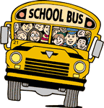DRIVER PROFILE

NAME:

SCHOOL DISTRICT:

LENGTH OF EMPLOYMENT:
TYPE OF RUN: REGULAR SPECIAL ED
MARRIED: YEARS: CHILDREN:
NAMES OF CHILDREN:
HAVE YOU COMPETED BEFORE?
WHEN: WHERE:
IF YES, WHERE DID YOU PLACE? (OPTIONAL)
WHAT ARE YOUR HOBBIES?
WHAT ARE YOUR GOALS?
HAVE YOU EVER WON AN AWARD?
WHAT FOR:

WHAT IS THE MOST UNUSUAL EXPERIENCE YOU HAVE HAD WHILE DRIVING THE BUS?________________________________________________

